PJClient version 1.7

By N5TM

Table of Contents

1. **Overview**
2. **User’s Guide**
   1. **Quick Start**
      1. **Setup**
   2. **General**
   3. **Selected User**
      1. **Click on a callsign**
      2. **Posting Messages**
      3. **Drop Down Options**
   4. **Timer**
   5. **Buttons and Text Boxes**
      1. **CQ**
      2. **QRV**
      3. **Running**
3. **Menu Items**
   1. **Options**
      1. **Setup**
      2. **Font**
      3. **Colors…**
      4. **History**
      5. **Chat Page Font**
      6. **Update Call3.txt**
   2. **View**
      1. **N5TM Chat**
      2. **DX Cluster**
   3. **Refresh…**
   4. **Web Links**
   5. **Help**
   6. **URL Select Drop Down**
4. **Selected User**
   1. **Highlighted lines**
   2. **Format**
5. **CQ QRV and Frequency Posting**
6. **Displayed User**
7. **Overview**

PJClient is a software program which poles PingJockey, EME-1, EME-1 or JT65 Terrestrial pages. It then reformats the pages into a more easily viewed screen.

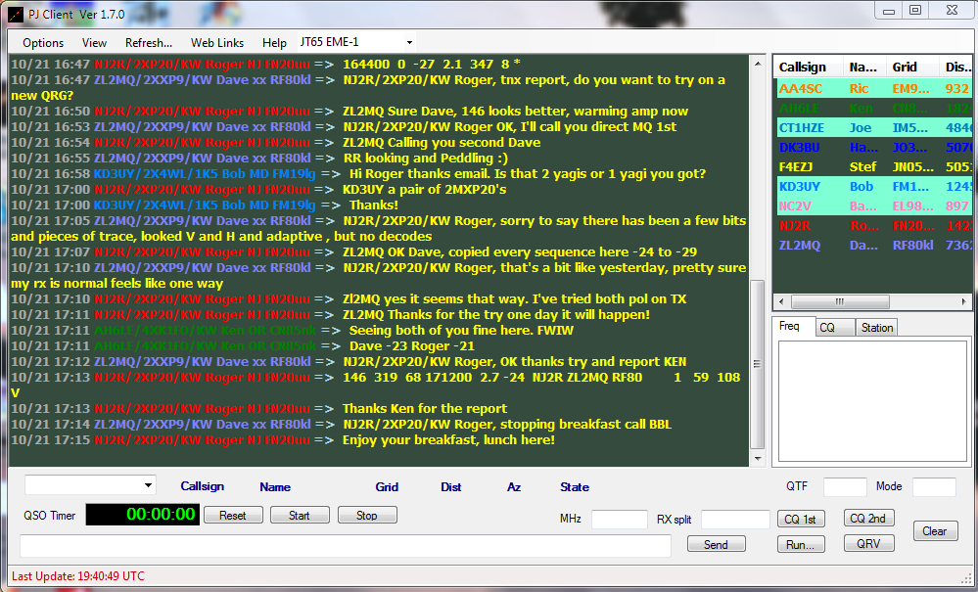

The software poles each page in the background and watches for changes. All changes are then displayed in near real-time. No waiting for the one minute refresh on the actual pages.

Additionally, there is no annoying refresh right in the middle of typing a message.

1. **User’s Guide**
   1. **Quick Start**
      1. **Setup**

In order for PJClient to spoof the web pages into thinking you are using a browser, it must set cookies to emulate what the browser page does after you fill in your personal information (Callsign, name, grid, etc..)

From the “Options” menu, select “Setup”.

The Setup Dialog box will then be displayed.

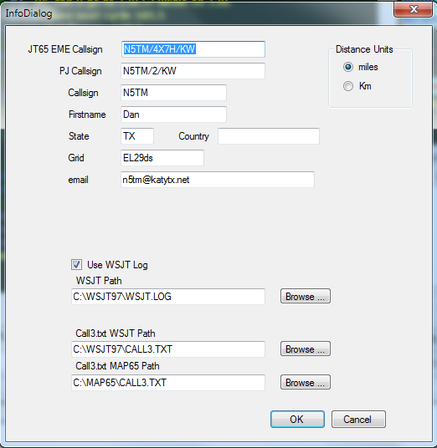

**JT65 EME Callsign –** This is how you want your posts displayed on EME pages.

(example: N5TM/4X7H/KW)

**PJ Callsign –** This is how you want your posts displayed on Ping Jockey

(example: N5TM/6m/QRO)

**Callsign –** Enter your callsign here.

**Firstname –** Your first name

**State –** State

**Country –** optional

**Grid –** your grid square

**Email –** optional

**Use WSJT Log –** check if you want PJClient to scan your WSJT log for contacts.

**WSJT Path -** use the browse button to find the folder where your WSJT.LOG file is located.

**Call3.txt Path –** use the browse button to find the folder where your Call3.txt file for WSJT and MAP65 are located

* 1. **General**

As the page is scanned each user on the page is listed in the upper right box and assigned a color. 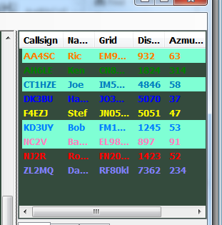

You can track the posts from particular users via the color. Note the highlighted lines. This indicates that callsign was found in WSJT.Log file which means you have worked this station before on some WSJT mode.

* 1. **Selected User**
     1. **Click on a callsign**

If you click on a user in the upper right box any future posts from that user are highlighted and also displayed in the station tab of the lower right box.

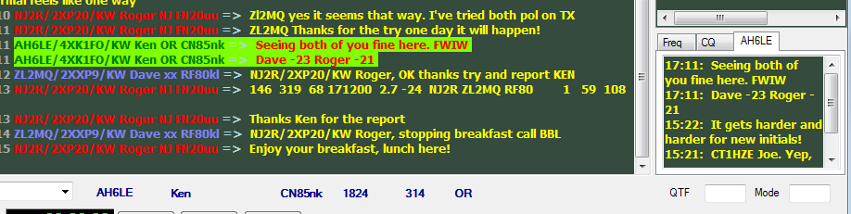

* + 1. **Posting Messages**

It’s easy to miss a post from someone. PJClient watches for your callsign in all posted messages and highlights that message so you will know someone has addressed a message to you.



To facilitate the embedding of callsigns in messages a feature is included to pre-build the callsign and name of the selected person you wish to address. To do this, click the “name” field as below before typing the message.

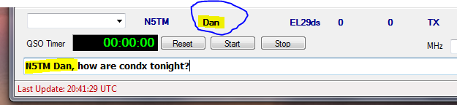

* + 1. **Drop Down Options**

The dropdown box to the left of the callsign can be used to display info on this user, post canned messages, or send an email.

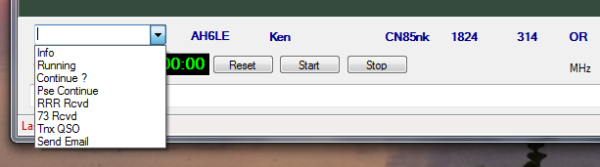

* 1. **Timer**

A Timer is included to indicate how long you have been attempting the contact.

This timer can be started by clicking the “Start” button. It is also started if the “Running” message is selected from the drop down.

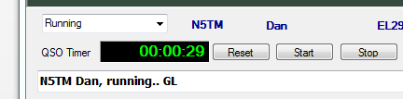

If you select the Tnx QSO message while on the Ping Jockey page the distance and time of the contact is also displayed.

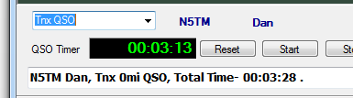

On EME pages “Best-“ is displayed

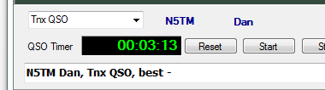

* 1. **Buttons and Text Boxes**
     1. **CQ**
     2. **QRV**
     3. **Running**

1. **Menu Items**
   1. **Options**
      1. **Setup**
      2. **Font**
      3. **Colors…**
      4. **History**
      5. **Chat Page Font**
      6. **Update Call3.txt**
   2. **View**
      1. **N5TM Chat**
      2. **DX Cluster**
   3. **Refresh…**
   4. **Web Links**
   5. **Help**
   6. **URL Select Drop Down**
2. **Selected User**
   1. **Highlighted lines**
   2. **Format**
3. **CQ QRV and Frequency Posting**
4. **Displayed User**